Hello Sea Watchers!

We can’t believe it’s nearly June, and our second group of interns is about to arrive! We’ve had a good start to the season with many dolphin sightings, although it has been too windy at times to head out on the boats, but we’re hoping this will change again soon so we can get back out on the water and spot some fins!

New Quay is becoming steadily busier as we approach the summer holidays and our interns have been busy chatting to visitors about our dolphins. One of the most common question we get is about the dolphin ‘families’ in Cardigan Bay. A lot of people assume that when they see a pod of dolphins that it is a family unit with parents and their kids, much like many of the holiday makers. However, dolphin society is quite different to ours - our dolphins live in what is termed a fission-fusion society (they are social and enjoy other dolphins’ company but they often change who they hang out with). They might spend time in large groups when they’re feeding and then split off into smaller groups when they go off to do other things.

Adult male and female dolphins also prefer to spend time with individuals of the same gender. Female dolphins will often help each other take care of calves and in more dangerous parts of the world, they also stick together for safety away from predators such as sharks. Of course, female dolphins have strong bonds with their calves, our adoptable dolphin **Chris** famously stayed with his mum until he was seven! Dolphin daughters may also return to spend time with their mums once they are adults, possibly to learn more about taking care of dolphin calves and helping out with their siblings.

Although dolphins may have many casual acquaintances, they do form longer lasting bonds as well. **Ghost** and **Berry** are often seen together but her strongest association is actually with **Gabby**, another older female dolphin. It’s not just the girls who form long lasting attachments though, **Frodo** and **Dumbledore** have had a long lasting ‘bromance’ and we rarely see one without the other. It’s so sweet!

Different types of dolphins have different preferences, and there is even some variation between bottlenose dolphins in different parts of the world. We don’t think we know all the intricacies of our dolphin society in Cardigan Bay, and we look forward to learning more about our dolphins as the years go by. For now though, read on and find out who we spotted this month!

Lots of love,

Katrin

Photo-ID

At the end of last month, just before the newsletter went out, we spotted **Flint** in one of our first surveys of northern Cardigan Bay. We used to see **Flint** regularly around New Quay, but in recent years he seems to have shifted his range north so we only see him on our surveys there.

We also saw **Lumpy** feeding with some of his friends not far from New Quay, and we have since spotted him again on one of our early morning surveys, chasing fish and feeding off the bird colonies in New Quay. He was very pre-occupied with his breakfast, who can blame him, and it took us a while to catch up with him but eventually he reluctantly posed for a picture before going back to his food!

**Ghost** and **Spirit** continued to be regularly sighted around New Quay, delighting interns and visitors alike. This month we did not see her with her friend **Berry,** but we did spot **Berry** and **Luna** with two other mums and calves around Ynys Lochtyn on one of our surveys. The calves were very playful and showed off to the boat, breaching and playing while the mums took a well-deserved rest!

We also caught up with some of our other dolphin mums, **Spot** and **Sooty** and their calves feeding around Aberporth headland.

Hi there

Wow, just look at these amazing photographs of common dolphins in Devon!  
Taken by Rob Hughes, of Devon Sea Safari, they are so crystal clear you can almost see every mark on the animals.

[Devon Sea Safari](https://www.facebook.com/devonseasafari?__cft__%5b0%5d=AZUj5AZR7OLEgGQn-m8qgT4jxUejKMTG0WXEB9cdw8vhe_gbs5VJVGoaEXKEcGIhs4hN2oi33VzWnphXZ1CLRTvS_LcjWbi8qeW07GvvcbM0VeYpIzmvJjHA7VFYYvfVTngaZO8cUrDPoEfwBC9LdAD1v2EfTCeall86U9NaH-59Wvdbq3pA-vn145GVqcGV4KY&__tn__=-%5dK-R) is one of our recommended boat operators in the south-west and they snapped these recently while out on one of their wildlife trips off Torbay! Common dolphins are a protected species, and it is always exciting to see them in the wild.

If you are interested in learning more about common dolphins or seeing them for yourself, we encourage you to book a trip with Devon Sea Safaris. Being a member of our Recommended Boat Operator Scheme, means they have been trained to operate in a way that is safe for both people and wildlife.

Did you know we had our annual Orca Watch event in May? It was a five-day fin-tastic wildlife extravaganza of fin, mike and humpback whales, rissos dolphins, harbour porpoise, bottlenose dolphins and of course Orca!! The visitors who joined us up in Scotland were not disappointed, some having travelled a long distance just to get a distant glimpse of a killer whale. I would describe their reaction as ‘thrilled’!

Nurdles-the tiny plastic that’s become a big problem

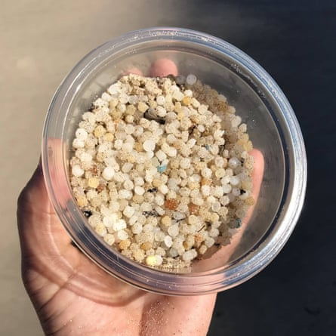Nurdles are micro plastic - tiny plastic pellets roughly the size of a lentil that although are tiny, are causing serious pollution to our oceans. For a long while, they have been used in the process of making all things plastic, such as bottle tops, and food containers. Unfortunately, during the manufacturing process of these items, nurdles are lost and end up entering our ocean through storm drains, spillages and other methods. Within the EU alone, it is estimated that every day up to 23 billion nurdles end up joining those already in the ocean. This is an roughly equal to an astounding 15 billion plastic bottles!

First recorded in 1970, the nurdle problem is now so vast that nurdles have been noted on every continent except for Antarctic. As the nurdle pollution grows, scientists and conservationists are realising the negative impact that these tiny plastics are having on marine life around the globe. There are now calls for nurdle pollution to be more closely monitored. However, one of the biggest challenges is that, like other micro plastics, the tiny size of nurdles makes them difficult to remove once in the environment.

Nurdles often attract chemicals to their surface

© K Berger/PA

In addition, the small size of nurdles means they are easily consumed in large amounts by marine animals, and so, quickly accumulate in large numbers within food webs. For example, turtles, dolphins and seabirds are all examples of species that have had deaths linked to these micro plastics. Worse still, nurdles also readily absorb chemicals used within plastic production in large quantities. These chemicals are then leeched into the surrounding environment once the nurdles enter the ocean. The released toxins can also directly harm the wildlife’s biological systems as the plastics build up internally. This will then further build up and impact different levels of the food web. Studies have even indicated that micro plastics like nurdles are found within the seafood we eat, and more shockingly, since 2020 onwards, have been found inside us humans!

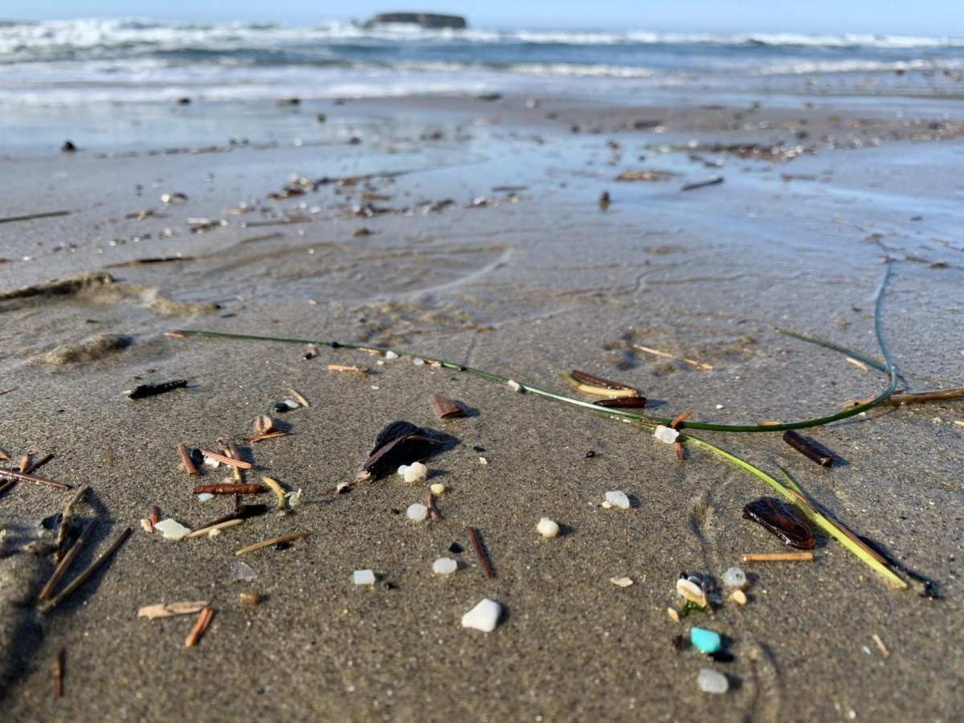

Recent research has indicated that newer nurdles are also more harmful to the environment then older ones, as they contain higher amounts of the chemicals that are able to leech into ocean. Luckily, things are being set in motion that will hopefully change the population’s outlook on nurdles. This includes legislative proposals and campaigns in aid of providing more legislation and restrictions over the levels of nurdle pollution we currently see. Every new restriction and method of monitoring and reducing nurdle levels and other micro plastics within the ocean is a splash in the right direction.

nurdles on a beach ©Oceanblueproject/Ana Mexia

We also know that topics like this can sometimes be overwhelming, but there are still lots we can do to tackle all kinds of pollution to help improve our marine environment, remember, every little bit makes a difference! There are lots of movements and projects spreading the word about nurdles and volunteer activities to get involved in - carrying out nurdle hunts and reporting findings. ***The Nurdle Hunt*** organisation is one of the most well-known out there and you can find out more about it [**here**](https://www.nurdlehunt.org.uk/)

You can download a handy **Nurdle Hunt ID** sheet from their website which is packed full of great pictures and information!